**ALGORITHM PRESENTATION OF BUBBLE SORT**

1. **Idea**

Bubble sort is a basic algorithm for arranging a string of numbers or other elements in the correct order. The method works by examining each set of adjacent elements in the string, from left to right, switching their positions if they are out of order. The algorithm then repeats this process until it can run through the entire string and find no two elements that need to be swapped.

1. **How it works**

Consider Input: arr[] = {6, 3, 0, 5}



Explanation:

First loop: Repeat n-1 times (n = number of elements in the array, in this case, n = 4)

* Compare adjacent elements from left to right.
* If the left element is greater than the right element, swap them.
* After each iteration, the largest unsorted element "bubbles up" to the end of the array.

Step 1: Compare 6 > 3, swap 6 and 3: {3, 6, 0, 5}

Step 2: Compare 6 > 0, swap 6 and 0: {0, 3, 6, 5}

Step 3: Compare 6 > 5, swap 6 and 5: {0, 3, 5, 6}

The largest element, 6, is now in its correct sorted position at the end of the array.



Second loop: Repeat n-2 times (as the largest element is already sorted, no need to consider it)

* Repeat the same process, but now the last element is in its correct sorted position.

Step 1: Compare 0 < 3, no swap, array remains unchanged: {0, 3, 5, 6}

Step 2: Compare 3 < 5, no swap, array remains unchanged: {0, 3, 5, 6}

The second-largest element, 5, is now in its correct sorted position.



Third loop: Repeat n-3 times (the last two elements are already sorted)

* Repeat the same process.

Step 1: Compare 0 < 3, no swap, array remains unchanged: {0, 3, 5, 6}

The remaining 2 elements, 0 and 3 are now in their correct sorted positions.

1. **Time complexity**

Worst-case: O(n2)

Average-case: O(n2)

Best-case: O(n) – Due to a flag variable that is set to false before each pass and is set to true when swapping occurs (Improved version)

1. **Space complexity: O(1)**
2. **Variants of bubble sort**

**Odd-Even/Brick sort:** This algorithm is divided into two phases- Odd and Even Phase. The algorithm runs until the array elements are sorted and in each iteration two phases occurs- Odd and Even Phases. In the odd phase, we perform a bubble sort on odd indexed elements and in the even phase, we perform a bubble sort on even indexed elements.

**Shaker/Cocktail sort:** Cocktail Sort, a variation of Bubble Sort, improves efficiency by traversing through the array bidirectionally. In each iteration, it performs two stages: the first stage moves from left to right, swapping adjacent elements to move the largest element to its correct position at the end of the array; the second stage moves from right to left, placing the second-largest element in its proper position. These stages alternate until the entire array is sorted.

**ALGORITHM PRESENTATION OF SHAKER SORT**

1. **Idea**

The Bubble sort algorithm always traverses elements from left and moves the largest element to its correct position in the first iteration and second-largest in the second iteration and so on, while Shaker Sort (variant of bubble sort) traverses through a given array in both directions alternatively. Shaker sort does not go through the unnecessary iteration making it efficient for large arrays.

Shaker sorts break down barriers that limit bubble sorts from being efficient enough on large arrays by not allowing them to go through unnecessary iterations on one specific region (or cluster) before moving onto another section of an array.

1. **How it works**

Consider Input: arr[] = {8, 7, 4, 8, 1}

Left to right:

First loop: Repeat n-1 times (n = number of elements in the array, in this case, n = 5)

* Compare adjacent elements from left to right.
* If the left element is greater than the right element, swap them.
* After each iteration, the largest unsorted element "bubbles up" to the end of the array.

Step 1: Compare 8 > 7, swap 8 and 7: {7, 8, 4, 8, 1}

Step 2: Compare 8 > 4, swap 8 and 4: {7, 4, 8, 8, 1}

Step 3: Compare 8 = 8, no swap, array remains unchanged: {7, 4, 8, 8, 1}

Step 4: Compare 8 > 1, swap 8 and 1: {7, 4, 8, 1, 8}

The largest element, 8, is now in its correct sorted position at the end of the array.

Right to left:

Second loop: Repeat n-2 times (as the largest element is already sorted, no need to consider it)

* Compare adjacent elements from right to left.
* If the left element is greater than the right element, swap them.
* After each iteration, the smallest unsorted element "falls down" to the beginning of the array.

Step 1: Compare 1 < 8, swap 1 and 8: {7, 4, 1, 8, 8}

Step 2: Compare 1 < 4, swap 1 and 4: {7, 1, 4, 8, 8}

Step 3: Compare 1 < 7, swap 1 and 7: {1, 7, 4, 8, 8}

The smallest element, 1, is now in its correct sorted position at the beginning of the array.

Left to right:

Third loop: Repeat n-3 times (the last and first elements are already sorted)

* Repeat the same process.

Step 1: Compare 7 > 4, swap 7 and 4: {1, 4, 7, 8, 8}

Step 2: Compare 7 < 8, no swap, array remains unchanged: {1, 4, 7, 8, 8}

The second-largest element, 8, is now in its correct sorted position.

Right to left:

Fourth loop: Repeat n-4 times (the first and last two elements are already sorted)

* Reapeat the same process.

Step 2: Compare 7 > 4, no swap, array remains unchanged: {1, 4, 7, 8, 8}

Step 3: Compare 4 > 1, no swap, array remains unchanged: {1, 4, 7, 8, 8}

Due to no swapping operations taking place, the array is now completely sorted.

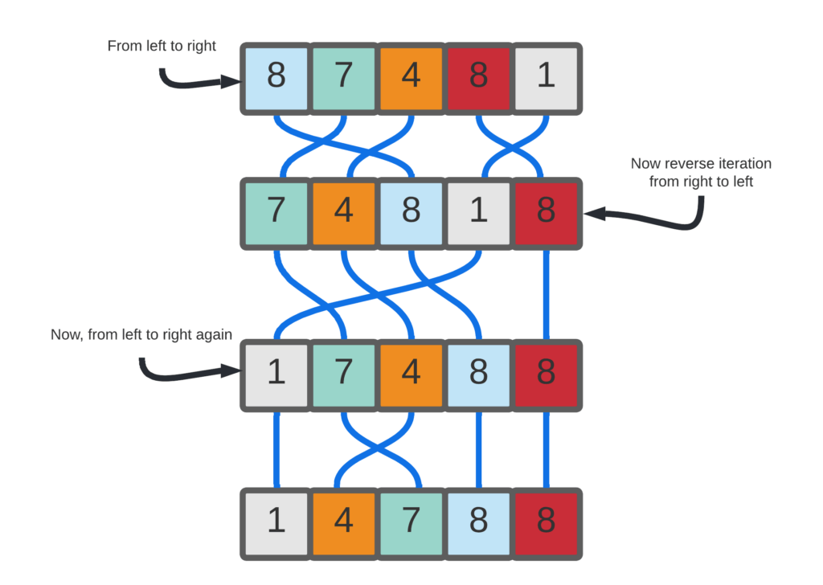

1. **Time complexity**

Worst-case: O(n2)

Average-case: O(n2)

Best-case: O(n)

1. **Space complexity: O(1)**

**ALGORITHM PRESENTATION OF COUNTING SORT**

1. **Idea**

Counting sort is a sorting technique based on keys between a specific range. It works by counting the number of objects having distinct key values (a kind of hashing). Then do some arithmetic operations to calculate the position of each object in the output sequence.

1. **How it works**

* Given an input array of positive integers with a range from 0 to a known maximum value (k).
* Create an auxiliary counting array of size k+1, initialized with all zeros. This counting array will be used to store the frequencies of each element in the input array.
* Traverse the input array and count the occurrences of each element. Increment the corresponding index in the counting array for each element encountered in the input array.
* Modify the counting array to represent the cumulative count of elements. Each element in the counting array will now indicate the position in the sorted output array.
* Create the output array with the same size as the input array.
* Traverse the input array again. For each element encountered, find its position in the output array using the value at the corresponding index in the counting array. Place the element in the output array at that position.
* Decrement the count in the counting array for the processed element.
* Repeat the process for all elements in the input array.
* The output array now contains the sorted elements in ascending order.

Consider Input: arr[] = {1, 4, 1, 2, 7, 5, 2} (For simplicity, consider the data in the range of 0 to 9).

Step 1: Take a count array to store the count of each unique object.



Step 2:

* Store the count of each unique element in the count array.
* If any element repeats itself, simply increase its count.

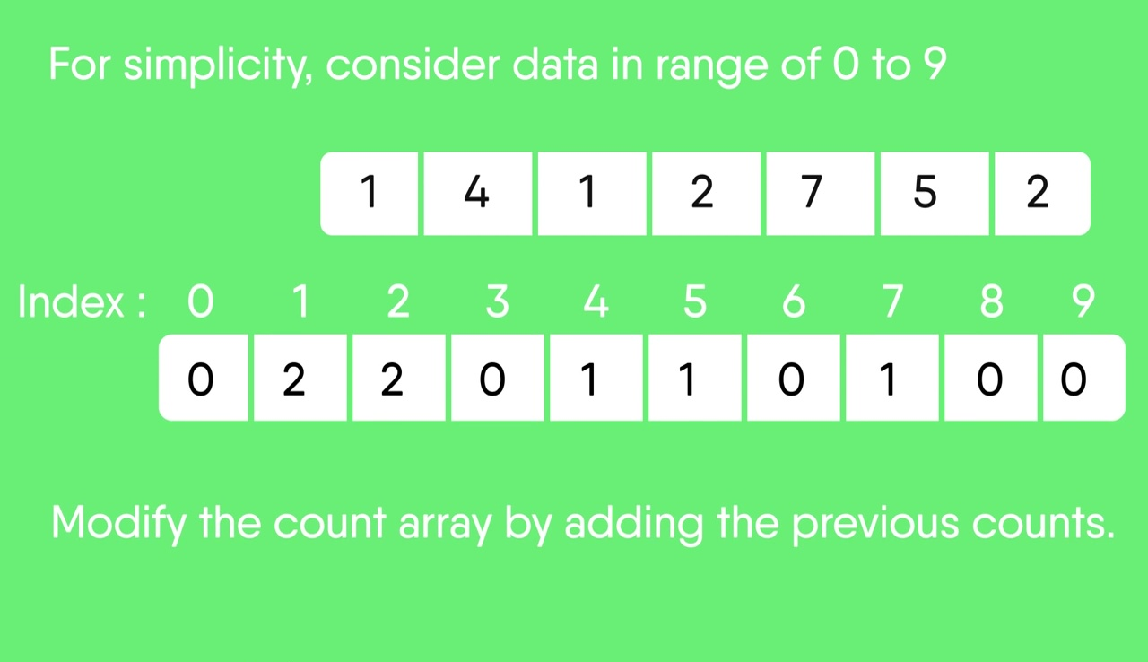

Step 3:

* Modify the count array such that each element at each index stores the sum of previous counts.
* The modified count array indicates the position of each object in the output sequence.
* The modified count array indicates the position of each object in the output sequence.
  + Index: 0 1 2 3 4 5 6 7 8 9
  + Count: 0 2 4 4 5 6 6 7 7 7

Step 4: Using the index in count array to find the corresponding sorted position, before decrementing that index by 1. Reapeat until all indices equal 0 in count array.

Final sorted result:

|  |  |  |  |  |  |  |
| --- | --- | --- | --- | --- | --- | --- |
| 1 | 1 | 2 | 2 | 4 | 5 | 7 |

1. **Time complexity**

Worst-case: O(N + K)

Average-case: O(N + K)

Best-case: O(N + K)

*Note:*N is the number of elements in the input array and K is the range of input.

1. **Space complexity: O(N + K)**
2. **Variants/Improvements of counting sort**

**Bucket sort:** Bucket sort is a sorting technique that involves dividing elements into various groups, or buckets. These buckets are formed by uniformly distributing the elements. Once the elements are divided into buckets, they can be sorted using **counting sort** algorithm. Finally, the sorted elements are gathered together in an ordered fashion.

**Radix sort:** Radix Sort is a linear sorting algorithm that sorts elements by processing them digit by digit. It is an efficient sorting algorithm for integers or strings with fixed-size keys with **counting sort** often being a subroutine to improve efficiency. Rather than comparing elements directly, Radix Sort distributes the elements into buckets based on each digit’s value. By repeatedly sorting the elements by their significant digits, from the least significant to the most significant, Radix Sort achieves the final sorted order.

Reference:

<https://www.geeksforgeeks.org/radix-sort/>

<https://www.geeksforgeeks.org/bucket-sort-2/>

<https://stackoverflow.com/questions/14368392/radix-sort-vs-counting-sort-vs-bucket-sort-whats-the-difference#:~:text=Bucket%20sort%20is%20a%20generalization,only%20sort%20each%20bucket%20independently>.

<https://www.baeldung.com/cs/radix-vs-counting-vs-bucket-sort>

<https://www.geeksforgeeks.org/counting-sort/>

<https://www.baeldung.com/cs/cocktail-sort>

<https://www.geeksforgeeks.org/cocktail-sort/>

<https://www.geeksforgeeks.org/bubble-sort/>

<https://www.simplilearn.com/tutorials/data-structure-tutorial/bubble-sort-algorithm>

<https://www.geeksforgeeks.org/odd-even-sort-brick-sort/>

<https://www.simplilearn.com/tutorials/data-structure-tutorial/bubble-sort-algorithm#optimizing_bubble_sort_algorithm>

<https://www.geeksforgeeks.org/time-and-space-complexity-analysis-of-bubble-sort/>

<https://www.productplan.com/glossary/bubble-sort/#:~:text=Bubble%20sort%20is%20a%20basic,they%20are%20out%20of%20order>.